Variable Selection:

|  |  |  |  |  |
| --- | --- | --- | --- | --- |
| Characteristic | Univariate | Domain | Model | Note |
| Demographic |  |  |  |  |
| Age at enrollment (mean) | P<0.0001* | √ | √ |  |
| Gender (%female) | P<0.0001* | √ | √ |  |
| Ethnicity (%black) | P=0.66 | X |  |  |
| Socioeconomic |  |  |  |  |
| Income (%yes) | P=0.017* | X |  |  |
| Employment (%UE) | P=0.033* | X |  |  |
| Payer source for ARVs (%family/spouse) | P=0.017* | √ | √ |  |
| Housing (%rent/Own) | P=0.17 | X |  |  |
| Education (mean years) | P=0.0093* | √ | √ |  |
| Wealth Index 1 (mean) | P=0.83 | X |  |  |
| Wealth Index 2 (mean) | P=0.053* | X |  |  |
| Transportation (%personal vehicle) | P=0.0035 | √ | √ |  |
| Psychosocial |  |  |  |  |
| Traditional K-10 score (mean) | P<0.0001* | √ | √ | Depression_11 |
| Religious Faith (%yes) | P=0.0090* | √ | √ |  |
| Religious activity (%no religion/not active) | P=0.0001* | √ | √ |  |
| TM (%ever took) | P=0.69 | X |  |  |
| Stigma (%never) | P=1.00/0.66/0.35/0.62 | X |  |  |
| Partner HIV status (%0 partners) | P=0.017* | √ | √ | Family_hiv_bin |
| Total number of current partners (%0 partners) | P=0.0073* | X |  |  |
| Disclosed HIV status (%no) | P=0.072* | X |  |  |
| Practice safe sex (%always) | P=0.0003* | √ | √ | practice_safe_bin |
| Safe sex practice (%used condoms) | P=0.0014* | X |  |  |
| Have an ART supporter (%yes) | P=0.0036* | √ | √ |  |
| Clinic experience (%pleased) | P<0.0001* | √ | √ |  |

|  |  |  |  |  |
| --- | --- | --- | --- | --- |
| Characteristic | Univariate | Domain | Model | Note |
| Symptoms and Exam |  |  |  |  |
| Fever (%none) | P=0.025* | X |  |  |
| Fatigue (%none) | P<0.0001* | √ | √ |  |
| Memory (%none) | P=0.0029* | X |  |  |
| Nausea (%none) | P=0.0043* | X |  |  |
| Diarrhea (%none) | P=0.0052* | √ | √ |  |
| Sad (%none) | P=0.0004* | √ | √ |  |
| Nervous (%none) | P=0.0014* | √ | √ |  |
| Sleep(%none) | P=0.0016* | X |  |  |
| Rash (%none) | P=<0.0001* | √ | √ |  |
| Headache (%none) | P=0.016* | X |  |  |
| Gastrointestinal intolerance (%none) | P=0.057* | X |  |  |
| Sex problems (%none) | P=0.0005* | √ | √ |  |
| Weight Change (%none) | P=0.032* | X |  |  |
| Hair loss (%none) | P=0.029* | X |  |  |
| Pain (%none) | P=0.91 | X |  |  |
| Any symptom felt related to ARVs (%yes) | P=0.0078* | X |  |  |
| Karnofsky score (mean) | P=0.026* | X |  |  |
| Neurocognitive assessment | P=0.89 | X |  |  |
| Medical History |  |  |  |  |
| Recent CD4 count (median) | P=<0.0001* | X |  |  |
| Recent CD4 count (median log transformed) | P=<0.0001* | √ | √ |  |
| Recent CD4 count (%<350 cells/µL) | P=<0.0001* | X |  |  |
| Tuberculosis (%yes) | P=1.00 | X |  |  |
| Cryptococcal meningitis (%yes) | P=1.00 | X |  |  |
| Toxoplasmosis (%yes) | P=0.35 | √ | √ |  |
| Lipodystrophy (%yes) | P<0.0001 | √ | √ |  |
| Renal dysfunction (%yes) | P=0.52 | X |  |  |

|  |  |  |  |  |
| --- | --- | --- | --- | --- |
| Characteristic | Univariate | Domain | Model | Note |
| Medications |  |  |  |  |
| Duration ART (months) | P<0.0001* | √ | √ |  |
| Initiating ARV Clinic (%Sinikithemba) | P=0.013* | √ | √ |  |
| Recommended ART | P=0.0068* | √ | √ |  |
| Current ART regimen contains | P=0.0077* | √ | √ |  |
| HIV education and training sessions (%3+) | P=0.0050* | √ | √ | Arv_train_bin |
| Adherence counseling sessions | P<0.0001* | √ | √ |  |
| Mechanism to remember to take ARVs | P=0.44/0.060/0.0022* | √ | √ | remember_meds___7(Media) |
| Fluconazole use in the past 6 months (%yes) | P<0.0001* | √ | √ |  |
| Bactrim use in the past 6 months (%yes) | P=0.0001* | √ | √ |  |
| INH or RIF use in the past 6 months (%yes) | P=0.0005* | X |  |  |
| ETB use in the past 6 months (%yes) | P=0.014* | √ | √ |  |
| MPR (From Earliest Refill) | 0.23 | X |  |  |
| MPR (From Enrollment ) | 0.0008* |  | √ |  |
| Adherence | 0.0008* |  | √ |  |

**Model1 with designated variables:**

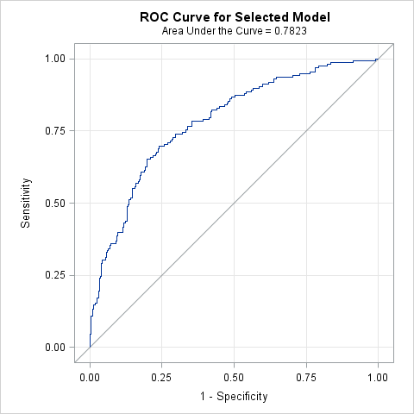

| **Hosmer and Lemeshow Goodness-of-Fit Test** | | |
| --- | --- | --- |
| **Chi-Square** | **DF** | **Pr > ChiSq** |
| 5.1857 | 8 | 0.7376 |

| **Odds Ratio Estimates and Profile-Likelihood Confidence Intervals** | | | | |  |  |
| --- | --- | --- | --- | --- | --- | --- |
| **Effect** | **Unit** | **Estimate** | **95% Confidence Limits** | | **P value** | **Type 3**  **P value** |
| **age** | 5.0000 | 0.798 | 0.691 | 0.916 | 0.0017 |  |
| **gender Male vs Female** | 1.0000 | 1.993 | 1.211 | 3.297 | 0.0068 |  |
| **ART Duration** | 1.0000 | 0.995 | 0.983 | 1.006 | 0.3890 |  |
| **pay Self Pay + Other vs Family Member/Spouse Pay** | 1.0000 | 0.659 | 0.358 | 1.222 | 0.1818 |  |
| **trans Transport to clinic: (Your car vs All Other)** | 1.0000 | 1.771 | 0.919 | 3.410 | 0.0866 |  |
| **Faith activity Not Active/No Religion vs Active** | 1.0000 | 1.636 | 1.030 | 2.604 | 0.0372 |  |
| **Family Members with HIV none vs 1-4** | 1.0000 | 0.619 | 0.384 | 0.996 | 0.0486 |  |
| **treat_support Yes vs No** | 1.0000 | 1.992 | 1.085 | 3.659 | 0.0258 |  |
| **rhiv Who first recommended you to go to an HIV clinic? (Friend vs Family)** | 1.0000 | 0.424 | 0.188 | 0.917 | 0.0329 | 0.0321 |
| **rhiv Who first recommended you to go to an HIV clinic? (Other vs Family)** | 1.0000 | 0.446 | 0.216 | 0.902 | 0.0264 |
| **rhiv Who first recommended you to go to an HIV clinic? (Provider vs Family)** | 1.0000 | 0.879 | 0.496 | 1.565 | 0.6602 |
| **arv_start Sinikithemba (Ridge House) vs Other** | 1.0000 | 0.504 | 0.235 | 1.086 | 0.0774 |  |
| **How Many Pre-ARV Sessions 3+ vs 0-2** | 1.0000 | 0.350 | 0.116 | 0.999 | 0.0537 |  |
| **ART regimen Other vs D4T** | 1.0000 | 0.489 | 0.279 | 0.853 | 0.0118 | 0.0420 |
| **ART regimen ZDV vs D4T** | 1.0000 | 0.617 | 0.296 | 1.270 | 0.1924 |
| **CO-TRIMOXAZOLE Yes vs No** | 1.0000 | 1.631 | 0.971 | 2.748 | 0.0647 |  |
| **FLUCONAZOLE Yes vs No** | 1.0000 | 4.976 | 1.422 | 23.256 | 0.0200 |  |
| **TBD ETHAMBUTOL Yes vs No** | 1.0000 | 2.734 | 0.746 | 11.414 | 0.1387 |  |

**Model 2 =Demo + Socioeconomic +Psycho + Symptoms + Medical History + Medications**

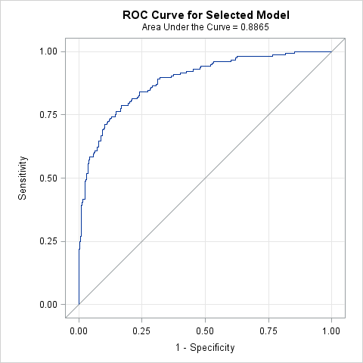

| **Hosmer and Lemeshow Goodness-of-Fit Test** | | |
| --- | --- | --- |
| **Chi-Square** | **DF** | **Pr > ChiSq** |
| 1.9360 | 8 | 0.9829 |

| **Odds Ratio Estimates and Profile-Likelihood Confidence Intervals** | | | | |  |  |
| --- | --- | --- | --- | --- | --- | --- |
| **Effect** | **Unit** | **Estimate** | **95% Confidence Limits** | | **P value** | **Type3 p value** |
| **age** | 5.0000 | 0.837 | 0.690 | 1.012 | 0.0689 |  |
| **gender Male vs Female** | 1.0000 | 2.258 | 1.230 | 4.187 | 0.0090 |  |
| **ART Duration** | 1.0000 | 1.001 | 0.986 | 1.016 | 0.8949 |  |
| **edu** | 1.0000 | 1.112 | 0.958 | 1.305 | 0.1767 |  |
| **trans Transport to clinic: (Your car vs All Other)** | 1.0000 | 1.788 | 0.771 | 4.174 | 0.1759 |  |
| **Depression Score 12+ vs 10 or 11** | 1.0000 | 3.134 | 1.692 | 5.985 | 0.0004 |  |
| **Faith activity Not Active/No Religion vs Active** | 1.0000 | 1.723 | 0.990 | 3.018 | 0.0552 |  |
| **Family Members with HIV none vs 1-4** | 1.0000 | 0.593 | 0.329 | 1.059 | 0.0789 |  |
| **Practice safe sex Often,Sometimes,Rarely,Never vs Always** | 1.0000 | 5.506 | 2.126 | 14.703 | 0.0005 |  |
| **treat_support Yes vs No** | 1.0000 | 1.910 | 0.866 | 4.187 | 0.1060 |  |
| **clinic_feel Pleased vs Neutral** | 1.0000 | 0.448 | 0.235 | 0.850 | 0.0141 |  |
| **symptom_fatigue Patient have symptom=Yes vs No** | 1.0000 | 2.529 | 1.381 | 4.690 | 0.0028 |  |
| **symptom_diarr Patient have symptom=Yes vs No** | 1.0000 | 2.548 | 1.042 | 6.212 | 0.0391 |  |
| **symptom_skin Patient have symptom=Yes vs No** | 1.0000 | 1.722 | 0.960 | 3.092 | 0.0677 |  |
| **log_cd4** | 1.0000 | 0.079 | 0.024 | 0.227 | <.0001 |  |
| **Lipodystrophy Yes vs No** | 1.0000 | 0.428 | 0.209 | 0.843 | 0.0166 |  |
| **arv_start Sinikithemba (Ridge House) vs Other** | 1.0000 | 0.441 | 0.179 | 1.087 | 0.0739 |  |
| **rhiv Who first recommended you to go to an HIV clinic? (Friend vs Family)** | 1.0000 | 0.311 | 0.116 | 0.794 | 0.0170 | 0.0311 |
| **rhiv Who first recommended you to go to an HIV clinic? (Other vs Family)** | 1.0000 | 0.376 | 0.153 | 0.892 | 0.0289 |
| **rhiv Who first recommended you to go to an HIV clinic? (Provider vs Family)** | 1.0000 | 0.761 | 0.379 | 1.532 | 0.4419 |
| **ART regimen Other vs D4T** | 1.0000 | 0.455 | 0.229 | 0.899 | 0.0237 | 0.0757 |
| **ART regimen ZDV vs D4T** | 1.0000 | 0.647 | 0.266 | 1.546 | 0.3296 |
| **adherence counseling sessions 2-4 vs 0-1** | 1.0000 | 0.370 | 0.147 | 0.917 | 0.0324 | 0.1012 |
| **adherence counseling sessions 5+ vs 0-1** | 1.0000 | 0.416 | 0.145 | 1.170 | 0.0991 |
| **Take Meds by Media(TV/Radio) Yes vs No** | 1.0000 | 3.517 | 1.400 | 8.954 | 0.0076 |  |
| **CO-TRIMOXAZOLE Yes vs No** | 1.0000 | 0.627 | 0.312 | 1.247 | 0.1853 |  |
| **FLUCONAZOLE Yes vs No** | 1.0000 | 2.637 | 0.474 | 18.611 | 0.2981 |  |
| **TBD ETHAMBUTOL Yes vs No** | 1.0000 | 2.803 | 0.553 | 15.206 | 0.2165 |  |

**Model 3 =Demo + Socioeconomic +Psycho + Access**

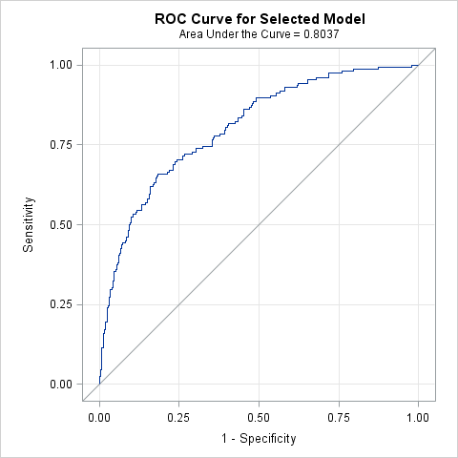

| **Hosmer and Lemeshow Goodness-of-Fit Test** | | |
| --- | --- | --- |
| **Chi-Square** | **DF** | **Pr > ChiSq** |
| 4.2964 | 8 | 0.8294 |

| **Odds Ratio Estimates and Profile-Likelihood Confidence Intervals** | | | | |  |  |
| --- | --- | --- | --- | --- | --- | --- |
| **Effect** | **Unit** | **Estimate** | **95% Confidence Limits** | | **P value** | **Type3**  **P value** |
| **age** | 5.0000 | 0.852 | 0.721 | 1.003 | 0.0572 |  |
| **gender Male vs Female** | 1.0000 | 2.646 | 1.606 | 4.406 | 0.0002 |  |
| **ART Duration** | 1.0000 | 0.990 | 0.980 | 0.999 | 0.0417 |  |
| **pay Self Pay + Other vs Family Member/Spouse Pay** | 1.0000 | 0.656 | 0.359 | 1.204 | 0.1714 |  |
| **edu** | 1.0000 | 1.132 | 1.001 | 1.294 | 0.0568 |  |
| **trans Transport to clinic: (Your car vs All Other)** | 1.0000 | 1.950 | 0.976 | 3.916 | 0.0589 |  |
| **Depression Score 12+ vs 10 or 11** | 1.0000 | 3.372 | 2.064 | 5.625 | <.0001 |  |
| **Faith activity Not Active/No Religion vs Active** | 1.0000 | 1.469 | 0.916 | 2.358 | 0.1106 |  |
| **Family Members with HIV none vs 1-4** | 1.0000 | 0.690 | 0.430 | 1.106 | 0.1232 |  |
| **Practice Safe Sex Often,Sometimes,Rarely,Never vs Always** | 1.0000 | 3.136 | 1.464 | 6.925 | 0.0037 |  |
| **treat_support Yes vs No** | 1.0000 | 1.850 | 1.005 | 3.415 | 0.0480 |  |
| **clinic_feel Pleased vs Neutral** | 1.0000 | 0.358 | 0.206 | 0.615 | 0.0002 |  |
| **Access(MPR)** | 0.1000 | 1.290 | 1.053 | 1.615 | 0.0188 |  |

**Model 4 =Demo + Psycho + Symptoms + Medical History + Medications + Adherence**

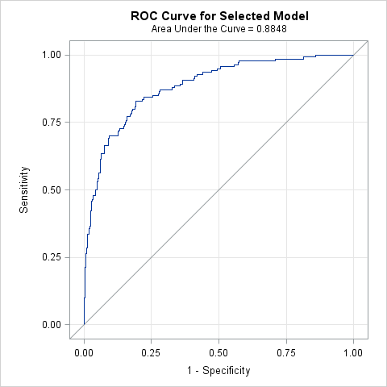

| **Hosmer and Lemeshow Goodness-of-Fit Test** | | |
| --- | --- | --- |
| **Chi-Square** | **DF** | **Pr > ChiSq** |
| 4.5765 | 8 | 0.8017 |

| **Odds Ratio Estimates and Profile-Likelihood Confidence Intervals** | | | | |  |  |
| --- | --- | --- | --- | --- | --- | --- |
| **Effect** | **Unit** | **Estimate** | **95% Confidence Limits** | | **P value** | **Type3 p value** |
| **age** | 5.0000 | 0.769 | 0.646 | 0.908 | 0.0024 |  |
| **gender Male vs Female** | 1.0000 | 2.584 | 1.398 | 4.843 | 0.0027 |  |
| **ART Duration** | 1.0000 | 1.006 | 0.991 | 1.022 | 0.4600 |  |
| **Depression Score 12+ vs 10 or 11** | 1.0000 | 3.077 | 1.653 | 5.903 | 0.0005 |  |
| **Faith Activity Not Active/No Religion vs Active** | 1.0000 | 1.741 | 0.990 | 3.087 | 0.0553 |  |
| **Family Members with HIV none vs 1-4** | 1.0000 | 0.588 | 0.324 | 1.060 | 0.0781 |  |
| **Practice safe sex Often,Sometimes,Rarely,Never vs Always** | 1.0000 | 5.576 | 2.021 | 15.932 | 0.0011 |  |
| **treat_support Yes vs No** | 1.0000 | 1.685 | 0.758 | 3.708 | 0.1957 |  |
| **clinic_feel Pleased vs Neutral** | 1.0000 | 0.463 | 0.240 | 0.890 | 0.0208 |  |
| **symptom_fatigue Patient have symptom=Yes vs No** | 1.0000 | 2.560 | 1.399 | 4.739 | 0.0025 |  |
| **symptom_diarr Patient have symptom=Yes vs No** | 1.0000 | 2.150 | 0.826 | 5.558 | 0.1139 |  |
| **symptom_skin Patient have symptom=Yes vs No** | 1.0000 | 1.724 | 0.937 | 3.175 | 0.0792 |  |
| **log_cd4** | 1.0000 | 0.066 | 0.020 | 0.194 | <.0001 |  |
| **Lipodystrophy Yes vs No** | 1.0000 | 0.516 | 0.251 | 1.025 | 0.0643 |  |
| **arv_start Sinikithemba (Ridge House) vs Other** | 1.0000 | 0.574 | 0.227 | 1.465 | 0.2395 |  |
| **rhiv Who first recommended you to go to an HIV clinic? (Friend vs Family)** | 1.0000 | 0.286 | 0.103 | 0.749 | 0.0130 | 0.0102 |
| **rhiv Who first recommended you to go to an HIV clinic? (Other) vs Family)** | 1.0000 | 0.325 | 0.130 | 0.778 | 0.0134 |
| **rhiv Who first recommended you to go to an HIV clinic? (Provider vs Family)** | 1.0000 | 0.874 | 0.432 | 1.778 | 0.7080 |
| **ART regimen Other vs D4T** | 1.0000 | 0.410 | 0.203 | 0.819 | 0.0120 | 0.0411 |
| **ART regimen ZDV vs D4T** | 1.0000 | 0.636 | 0.262 | 1.519 | 0.3123 |
| **adherence counseling sessions 2-4 vs 0-1** | 1.0000 | 0.460 | 0.168 | 1.246 | 0.1275 | 0.3004 |
| **adherence counseling sessions 5+ vs 0-1** | 1.0000 | 0.558 | 0.182 | 1.680 | 0.3014 |
| **Take Meds by Media(TV/Radio) Yes vs No** | 1.0000 | 3.057 | 1.242 | 7.638 | 0.0154 |  |
| **CO-TRIMOXAZOLE Yes vs No** | 1.0000 | 0.685 | 0.332 | 1.398 | 0.2998 |  |
| **Adherence** | 0.1000 | 1.321 | 1.005 | 1.754 | 0.0492 |  |

**Model 5 =Demo + Socioeconomic +Psycho + Symptoms + Medical History + Medications + Access + Adherence**

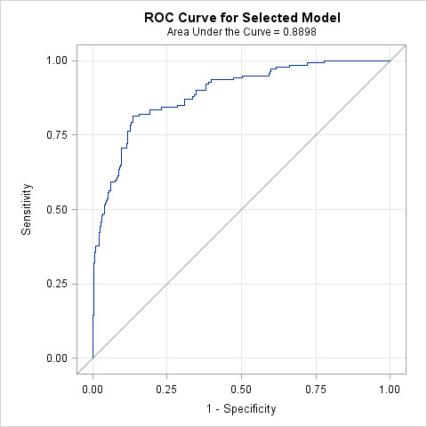

| **Hosmer and Lemeshow Goodness-of-Fit Test** | | |
| --- | --- | --- |
| **Chi-Square** | **DF** | **Pr > ChiSq** |
| 8.6736 | 8 | 0.3706 |

| **Odds Ratio Estimates and Profile-Likelihood Confidence Intervals** | | | | |  |  |
| --- | --- | --- | --- | --- | --- | --- |
| **Effect** | **Unit** | **Estimate** | **95% Confidence Limits** | | **P value** | **Type3**  **P value** |
| **age** | 5.0000 | 0.822 | 0.669 | 1.004 | 0.0579 |  |
| **gender Male vs Female** | 1.0000 | 2.484 | 1.315 | 4.762 | 0.0054 |  |
| **ART Duration** | 1.0000 | 1.006 | 0.991 | 1.022 | 0.4146 |  |
| **Adherence** | 0.1000 | 1.100 | 0.737 | 1.614 | 0.6337 |  |
| **edu** | 1.0000 | 1.146 | 0.986 | 1.351 | 0.0870 |  |
| **trans Transport to clinic: (Your car vs All Other)** | 1.0000 | 1.817 | 0.743 | 4.460 | 0.1899 |  |
| **Depression Score 12+ vs 10 or 11** | 1.0000 | 3.653 | 1.915 | 7.226 | 0.0001 |  |
| **Faith Activity Not Active/No Religion vs Active** | 1.0000 | 1.639 | 0.921 | 2.938 | 0.0937 |  |
| **Family Members with HIV none vs 1-4** | 1.0000 | 0.594 | 0.323 | 1.083 | 0.0905 |  |
| **Practice safe sex Often,Sometimes,Rarely,Never vs Always** | 1.0000 | 4.870 | 1.715 | 14.364 | 0.0034 |  |
| **treat_support Yes vs No** | 1.0000 | 1.742 | 0.771 | 3.898 | 0.1776 |  |
| **clinic_feel Pleased vs Neutral** | 1.0000 | 0.453 | 0.231 | 0.885 | 0.0204 |  |
| **symptom_fatigue Patient have symptom=Yes vs Patient have symptom=No** | 1.0000 | 2.446 | 1.310 | 4.615 | 0.0052 |  |
| **symptom_diarr Patient have symptom=Yes vs Patient have symptom=No** | 1.0000 | 2.118 | 0.821 | 5.416 | 0.1171 |  |
| **symptom_skin Patient have symptom=Yes vs Patient have symptom=No** | 1.0000 | 1.710 | 0.923 | 3.166 | 0.0871 |  |
| **log_cd4** | 1.0000 | 0.065 | 0.019 | 0.202 | <.0001 |  |
| **Lipodystrophy Yes vs No** | 1.0000 | 0.521 | 0.252 | 1.041 | 0.0705 |  |
| **rhiv Who first recommended you to go to an HIV clinic? (Friend vs Family)** | 1.0000 | 0.271 | 0.094 | 0.727 | 0.0116 | 0.0159 |
| **rhiv Who first recommended you to go to an HIV clinic? (Other vs Family)** | 1.0000 | 0.378 | 0.149 | 0.924 | 0.0359 |
| **rhiv Who first recommended you to go to an HIV clinic? (Provider vs Family)** | 1.0000 | 0.904 | 0.443 | 1.857 | 0.7809 |
| **ART regimen Other vs D4T** | 1.0000 | 0.372 | 0.181 | 0.756 | 0.0065 | 0.0233 |
| **ART regimen ZDV vs D4T** | 1.0000 | 0.609 | 0.243 | 1.495 | 0.2822 |
| **adherence counselling sessions 2-4 vs 0-1** | 1.0000 | 0.446 | 0.162 | 1.219 | 0.1138 | 0.2838 |
| **adherence counselling sessions 5+ vs 0-1** | 1.0000 | 0.471 | 0.151 | 1.441 | 0.1881 |
| **Take Meds by Media(TV/Radio) Yes vs No** | 1.0000 | 3.250 | 1.291 | 8.288 | 0.0125 |  |
| **CO-TRIMOXAZOLE Yes vs No** | 1.0000 | 0.663 | 0.319 | 1.361 | 0.2647 |  |
| **FLUCONAZOLE Yes vs No** | 1.0000 | 3.118 | 0.499 | 23.808 | 0.2467 |  |
| **Access(MPR)** | 0.1000 | 1.388 | 0.923 | 2.158 | 0.1295 |  |